

Department of Computer Science & Information Technology

Programme: Master of Science in Computer Science & Information Technology

[MSc-CS&IT]

Certificate
This is to certify that Mr. Ashish Khadela, Mr. Kaushal Muniwala and Mr. Yash Mandaliya has satisfactorily completed the course of Activity – 2 prescribed by the JAIN(Deemed-to-be-University) for the semester 2 M.Sc. – CS & IT degree course in the year 2024 - 2026.
Date: 01/04/2025

Signature of Student Head of the Department Signature of Faculty In charge



PROGRAM: MASTER OF SCIENCE IN COMPUTER SCIENCE AND INFORMATION TECHNOLOGY
[M.Sc. - CS & IT]

Mini Project
Student Management System

Semester - 2

Submitted To: Submitted By:

Dr M N Nachappa Ashish Khadela (24MSRCI012)
Prof. Haripriya V. Kaushal Muniwala (24MSRCI013)
Prof. Raghavendra R. Yash Mandaliya (24MSRCI028)

Student Management System

- Title Page

Project Title: Student Management System

Project Type: Mini Project

Course: Advance Database Management System
Human-Computer Interaction
Python Programming

Submitted By: Ashish Khadela (24MSRCI012)
Kaushal Muniwala (24MSRCI013)
Yash Mandaliya (24MSRCI028)

Date Of Submission: 01-04-2025

- Table Of Contents

- Abstract

- Introduction

- Objectives

- Technologies Used

- System Design

- Block Diagram

- Database Design

- User Interface Design

- Implementation

- Testing And Results

- Conclusion

- Future Enhancements

- References

- Abstract

The Student Management System (SMS) is a desktop-based application developed using Python (Tkinter) for the frontend and MySQL for the backend. The system provides functionalities such as student registration, course management, attendance tracking, result management, and user authentication (login, register, forgot password).

The project follows CRUD (Create, Read, Update, Delete) operations for database interactions and ensures a user-friendly interface with Tkinter GUI. The system helps educational institutions automate student data management efficiently.

- Dashboard for quick navigation
- Manage Course for adding, updating, and deleting courses
- Manage Students for student record management
- Manage Results for storing and retrieving student grades
- View Results for student performance analysis
- Manage Attendance for tracking student participation
- Authentication System with Login, Register, and Forgot Password

Key Technologies Used:

- Programming Language: Python
- Integrated Development Environment (IDE): VS Code
- Database Management System (DBMS): MySQL (using MySQL
Workbench)
- Human-Computer Interaction (HCI) Framework: Tkinter (for GUI
development)

- Introduction

Background
In educational institutions, managing student records, course enrollment, attendance, and academic performance is a critical yet time-consuming task. Traditionally, these processes are handled manually using paper-based records or spreadsheets, which often lead to inefficiencies, data inconsistency, and security issues.
To overcome these challenges, the Student Management System (SMS) has been developed as a desktop-based application using Python (Tkinter) for the frontend and MySQL for the backend. This system provides a structured approach to handling student-related operations, ensuring that data is securely stored, easily accessible, and efficiently managed.
The system supports essential functionalities such as student registration, course management, attendance tracking, result management, and user authentication. Additionally, it follows CRUD (Create, Read, Update, Delete) operations to facilitate seamless interactions with the database, allowing faculty and administrators to manage student information with ease.

Benefits of the Student Management System
- Automation & Efficiency
  - Eliminates manual record-keeping, reducing human errors and workload.
  - Enables quick data retrieval, updates, and deletion.
- Data Security & Integrity
  - MySQL database ensures secure storage with access control mechanisms.
  - Prevents unauthorized modifications with authentication protocols.
- Organized Academic Tracking
  - Faculty can analyze student performance efficiently through the View Results module.
  - Attendance and grade records are easily accessible for reporting and decision-making.
- Scalability & Future Enhancements
  - The system can be expanded to support more students, courses, and features.
  - Future upgrades may include data analytics, cloud integration, and AI-based recommendations.

Motivation
The motivation behind developing this Student Management System arises from the need to:
- Automate Student Data Management
  - Manual data entry and record-keeping are prone to errors and inefficiencies.
  - The system provides a structured, digital approach to store and retrieve student records effortlessly.
- Enhance Institutional Efficiency
  - Automating course management, attendance tracking, and result management reduces administrative workload.
  - A dashboard provides quick access to essential features, making navigation easier.
- Improve Data Accuracy & Security
  - Using MySQL as the database ensures data integrity and prevents unauthorized modifications.
  - The authentication system with Login, Register, and Forgot Password enhances security.
- Simplify Course & Student Management
  - Faculty members can add, update, and delete courses and student records efficiently.
  - Student performance can be analyzed through the View Results module.
- Streamline Attendance & Result Management
  - Tracking student participation is simplified through the Manage Attendance feature.
  - Storing and retrieving grades and performance records ensures organized academic tracking.
- Ensure a User-Friendly Experience
  - Tkinter GUI provides an interactive and visually appealing interface.
  - The CRUD-based approach makes operations intuitive for faculty and administrators.

Problem Statement
Educational institutions face challenges in efficiently managing student-related data, including enrollment, attendance, grades, and personal information. Manual processes or outdated systems often lead to errors, delays, and difficulties in accessing up-to-date records. Additionally, administrators, teachers, and students lack a centralized platform to streamline communication, track academic progress, and generate reports. This inefficiency hampers decision-making, increases administrative workload, and affects the overall educational experience. There is a need for an automated, user-friendly Student Management System to organize data, improve operational efficiency, and provide real-time access to stakeholders.

Educational institutions require an automated system to handle:
  - Student registration
  - Course allocation
  - Attendance tracking
  - Result management

Relevance of DBMS & HCI
- DBMS (MySQL) ensures structured data storage.
- HCI (Tkinter GUI) provides an intuitive user experience.

Report Overview
This document outlines system design, implementation, testing, and potential improvements.

- Objectives

- To develop a Tkinter-based GUI for easy interaction.
- To implement MySQL database for storing student records.
- To provide secure authentication (login, register, forgot password).
- To enable CRUD operations for students, courses, attendance, and results.
- To ensure user-friendly navigation (HCI principles).

- Technologies Used

Programming Language : Python

DBMS : MySQL

User Interface Tools : Tkinter

Other Tools : MySQL (MySQL
Workbench), VS Code

Libraries : mysql-connector-
python, tkinter,
messagebox, ttk

OS : Windows

- System Design

    - Block Diagram
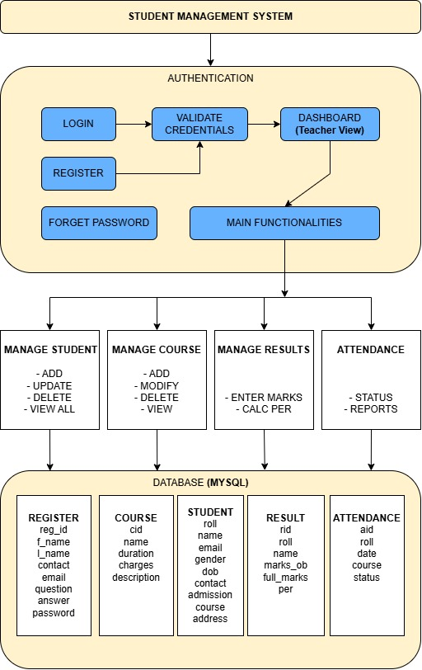

    - Database Design

- ER Diagram:

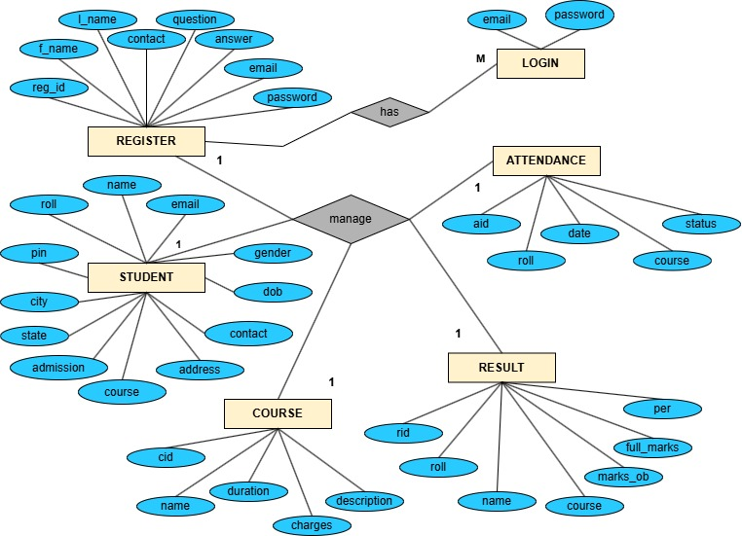

- Tables:
Manage Register
Column name | Data Type | Constraints | Description
reg_id _ID | INT(Primary Key, Auto Increment) | UNIQUE, NOT NULL | Unique identifier for faculty
F_name | VARCHAR(100) | NOT NULL | First name
L_name | VARCHAR(100) | NOT NULL | Last name
email | VARCHAR(100) | UNIQUE, NOT NULL | Faculty email for login
Contact | BIGINT | NOT NULL | Contact no of faculty
Question | VARCHAR(50) | NOT NULL | Question by system used later
Answer | VARCHAR(50) | NOT NULL | Used later at the time of forgot password
password | VARCHAR(255) | NOT NULL | Hashed password for authentication

Manage Course
Column name | Data Type | Constraints | Description
Course_ID | INT(Primary Key, Auto Increment) | UNIQUE, NOT NULL | Unique identifier for Courses
Course_name | VARCHAR(100) | NOT NULL | Course name
Duration | VARCHAR(50) | NOT NULL | Duration of course
Charges | INT | NOT NULL | Charges of particular course
Description | VARCHAR(100) | NOT NULL | Description of course

Manage Result
Column name | Data Type | Constraints | Description
Result_ID | INT(Primary Key, Auto Increment) | UNIQUE, NOT NULL | Unique identifier for Result
Course_ID | INT | FOREIGN KEY REFERENCES | Course ID
Student_id | INT | FOREIGN KEY REFERENCES | student ID
marks | INT | CHECK(marks BETWEEN 0 AND 100) | Marks obtained (0-100)
Full_marks | INT | CHECK(marks BETWEEN 0 AND 100) | Marks obtained (0-100)
per | VARCHAR(50) | NOT NULL | Percentage obtain

Manage Student
Column name | Data Type | Constraints | Description
Student_ID | INT(Primary Key, Auto Increment) | UNIQUE, NOT NULL | Unique identifier for student
name | VARCHAR(100) | NOT NULL | Student name
email | VARCHAR(100) | UNIQUE, NOT NULL | Student email for login
Gender | VARCHAR(20) | NOT NULL | Hashed password for authentication
Course_ID | INT | FOREIGN KEY REFERENCES | Foreign key of course table
State | VARCHAR(50) | NOT NULL | State of student
City | VARCHAR(50) | NOT NULL | City of student
Pin code | INT | NOT NULL | Pin code of student
Address | VARCHAR(250) | NOT NULL | Address of student
DOB | Date | NOT NULL | Date of birth of student
Contact NO | BIG INT | UNIQUE ,NOT NULL | Contact details of student
Admission Date | Date | NOT NULL | Date of admission of student

Manage Attendance
Column name | Data Type | Constraints | Description
Attendance_id | INT(Primary Key, Auto Increment) | UNIQUE, NOT NULL | Unique identifier for Result
Course_ID | INT | FOREIGN KEY REFERENCES | Course ID
Enrollment_id | INT | FOREIGN KEY REFERENCES | Enrollment ID
Date | DATE | NOT NULL | Attendance date
status | VARCHAR(10) | CHECK(status IN ('Present', 'Absent', 'Late')) | Attendance status

    - User Interface Design

- Wireframes

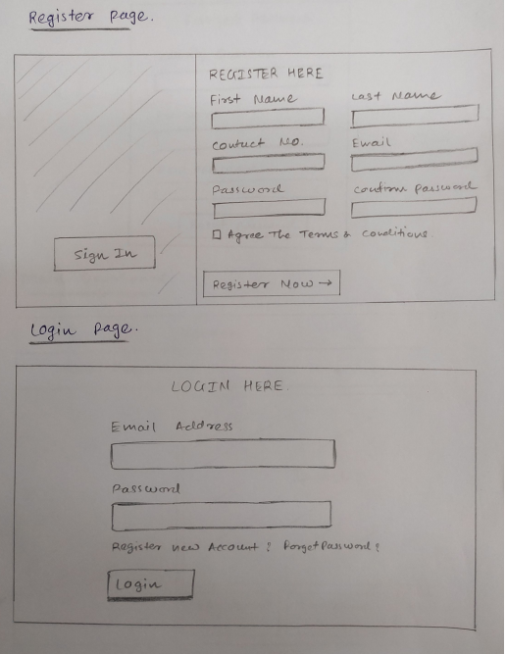

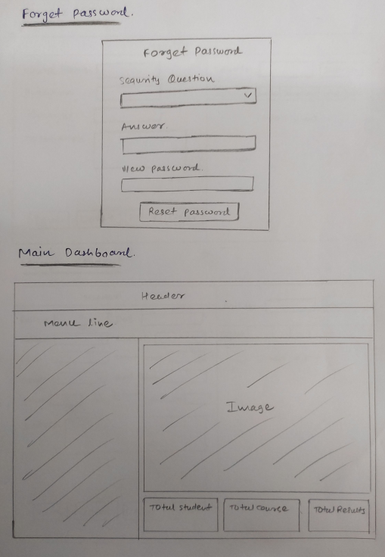

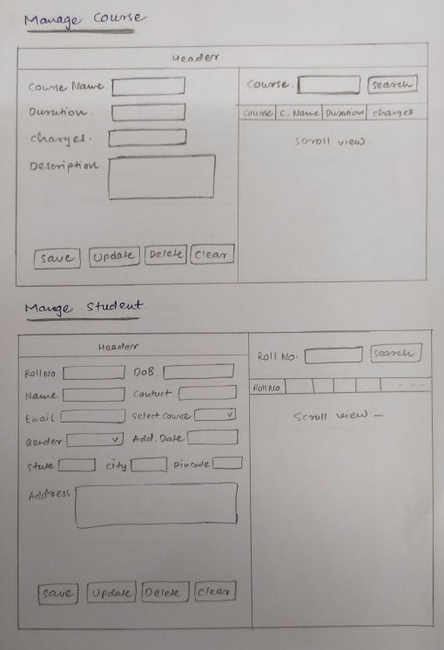

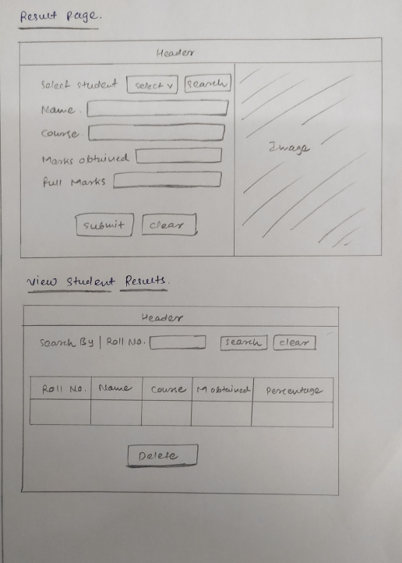

- Screenshots
- Register Form

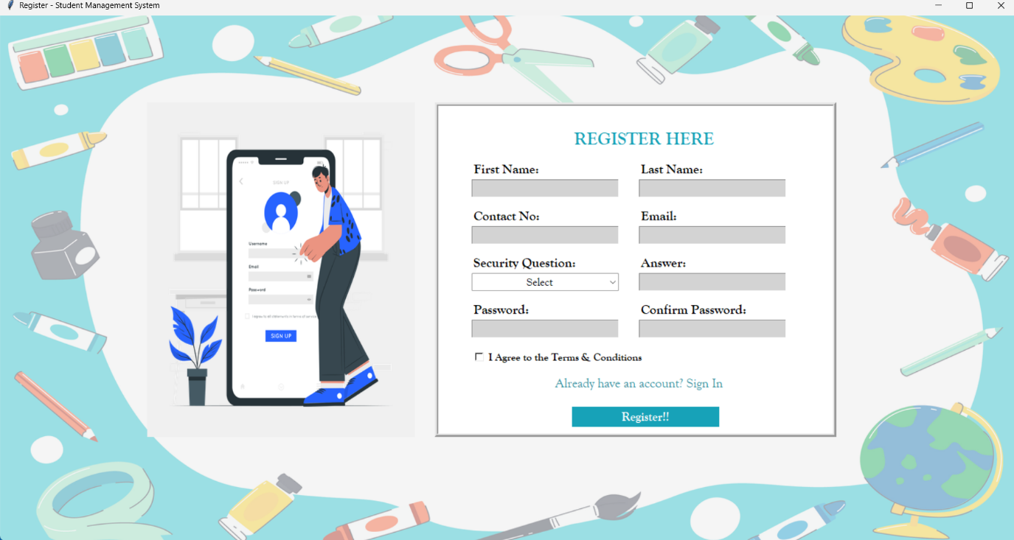

- Login Form
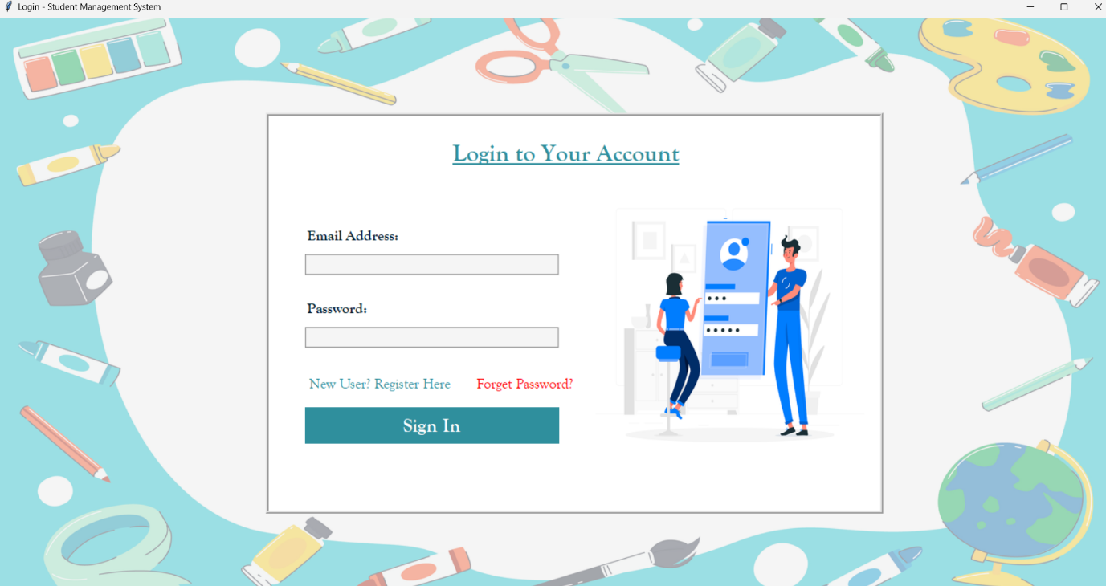

- Dash-Board Form


- Course Form
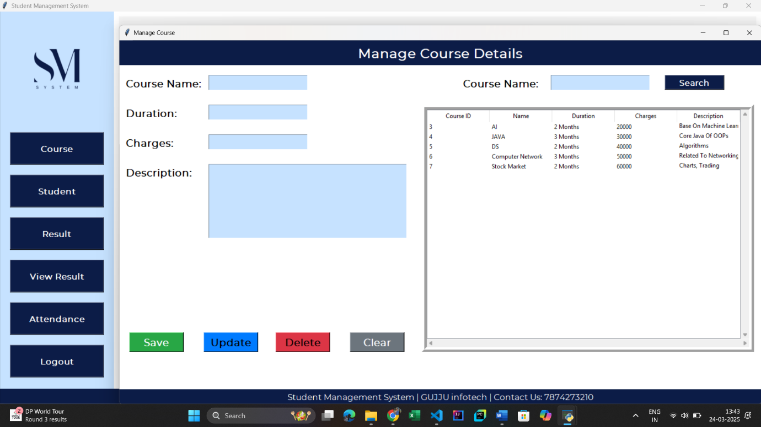

- Student Form
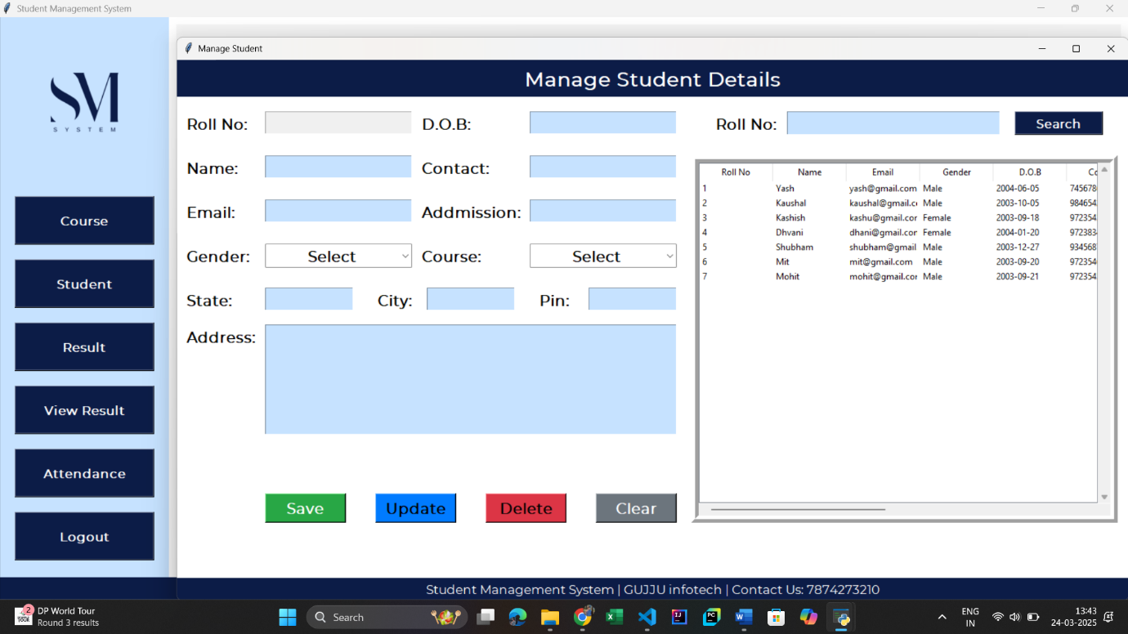

- Result Form
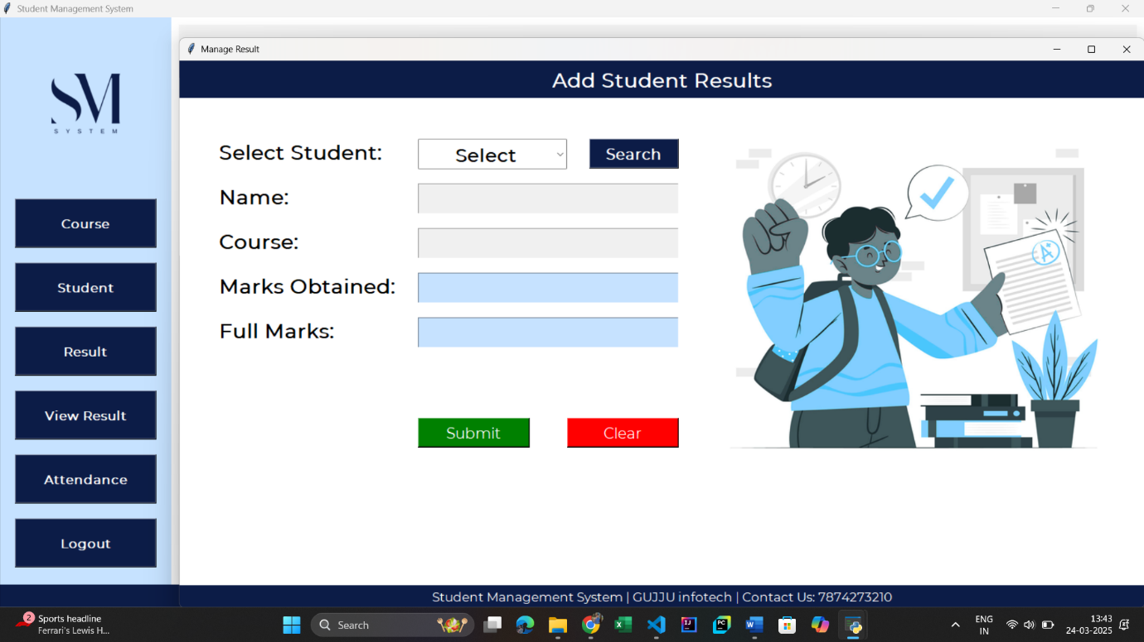

- View Result Form
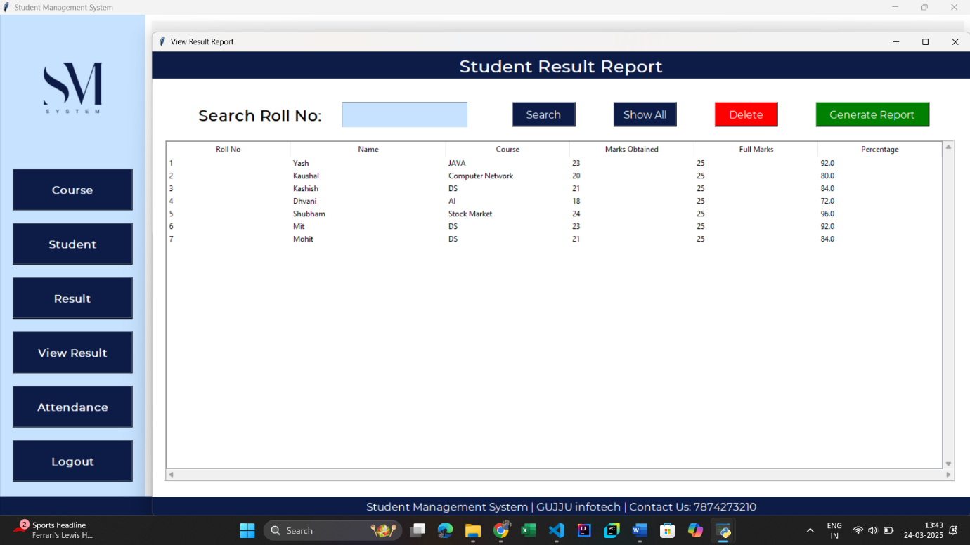

- Attendance Form

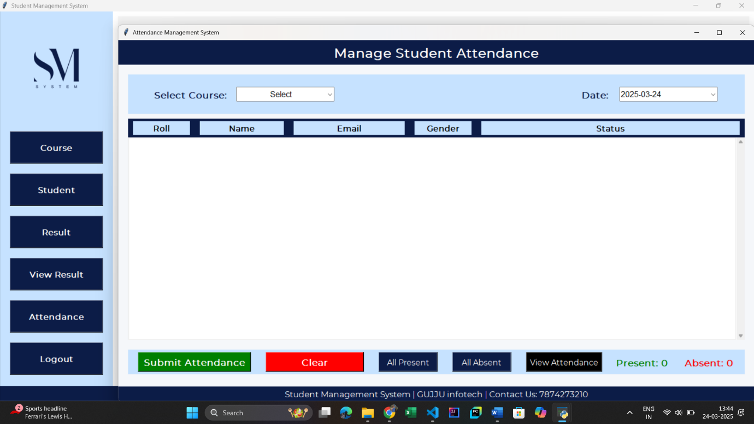

- Implementation
Database Interaction
import mysql.connector
def create_db():
try:
# Connect to MySQL
con = mysql.connector.connect(
host="localhost", # Change this if MySQL is running on another server
user="root", # Your MySQL username
password="Ashish@0629", # Your MySQL password
)
cur = con.cursor()
# Create database if not exists
cur.execute("CREATE DATABASE IF NOT EXISTS sms")
con.commit()
# Connect to the newly created database
con.database = "sms"
# Create course table
cur.execute("""
CREATE TABLE IF NOT EXISTS course(
cid INT AUTO_INCREMENT PRIMARY KEY,
name VARCHAR(255) UNIQUE, # Ensure course names are unique
duration VARCHAR(100),
charges VARCHAR(50),
description TEXT
)
""")
con.commit()
# Create student table with foreign key
cur.execute("""
CREATE TABLE IF NOT EXISTS student(
roll INT AUTO_INCREMENT PRIMARY KEY,
name VARCHAR(255),
email VARCHAR(255),
gender VARCHAR(10),
dob DATE,
contact VARCHAR(15),
admission DATE,
course VARCHAR(255),
state VARCHAR(100),
city VARCHAR(100),
pin VARCHAR(10),
address TEXT,
CONSTRAINT fk_course FOREIGN KEY (course) REFERENCES course(name) ON DELETE CASCADE
)
""")
con.commit()
# Create result table with foreign key
cur.execute("""
CREATE TABLE IF NOT EXISTS result(
rid INT AUTO_INCREMENT PRIMARY KEY,
roll INT,
name VARCHAR(255),
course VARCHAR(255),
marks_ob INT,
full_marks INT,
per FLOAT,
CONSTRAINT fk_student FOREIGN KEY (roll) REFERENCES student(roll) ON DELETE CASCADE
)
""")
con.commit()
# Create register table
cur.execute("""
CREATE TABLE IF NOT EXISTS register (
reg_id INT AUTO_INCREMENT PRIMARY KEY,
f_name VARCHAR(255) NOT NULL,
l_name VARCHAR(255) NOT NULL,
contact VARCHAR(15),
email VARCHAR(255) UNIQUE NOT NULL,
question VARCHAR(255),
answer TEXT,
password VARCHAR(255) NOT NULL -- Ensure password is always provided
)
""")
con.commit()
# Create attendance table with foreign key to course and student
cur.execute("""
CREATE TABLE IF NOT EXISTS attendance (
aid INT AUTO_INCREMENT PRIMARY KEY,
roll INT,
date DATE,
course INT,
status ENUM('P', 'A'),
CONSTRAINT fk_attendance_student FOREIGN KEY (roll) REFERENCES student(roll) ON DELETE CASCADE,
CONSTRAINT fk_attendance_course FOREIGN KEY (course) REFERENCES course(cid) ON DELETE CASCADE,
CONSTRAINT unique_attendance UNIQUE (roll, date, course)
)
""")
con.commit()
print("Database and Tables Created Successfully!")
con.close()
except mysql.connector.Error as err:
print(f"Error: {err}")
# Run the function to create the database and tables
create_db()

User Interface Development
1. Setting Up the Main Dash-Board Window
from tkinter import *
from PIL import Image, ImageTk
from course import CourseClass
from student import studentClass
from result import resultClass
from report import ReportClass
from attendance import AttendanceClass
from tkinter import messagebox
import os
import mysql.connector
class SMS:
def __init__(self, root):
self.root = root
self.root.title("Student Management System")
self.root.geometry("1520x785+0+0")
self.root.config(bg="white")
# Run Application
if __name__ == "__main__":
root = Tk()
obj = SMS(root)
print("Dashboard is running...")
root.mainloop()
2. Creating a Register Page
# Register Frame
Frame1 = Frame(self.root, bg="white")
Frame1.place(x=600, y=130, width=670, height=500)
title = Label(Frame1, text="REGISTER HERE", font=("montserrat", 20, "bold"), bg="white", fg="#17A2B8").place(x=50, y=30)
# Form Fields
f_name = Label(Frame1, text="First Name:", font=("montserrat", 15, "bold"), bg="white", fg="black").place(x=50, y=80)
self.txt_fname = Entry(Frame1, font=("montserrat", 15), bg="lightgray")
self.txt_fname.place(x=50, y=120, width=250)
l_name = Label(Frame1, text="Last Name:", font=("montserrat", 15, "bold"), bg="white", fg="black").place(x=370, y=80)
self.txt_lname = Entry(Frame1, font=("montserrat", 15), bg="lightgray")
self.txt_lname.place(x=370, y=120, width=250)
contact = Label(Frame1, text="Contact No:", font=("montserrat", 15, "bold"), bg="white", fg="black").place(x=50, y=150)
self.txt_contact = Entry(Frame1, font=("montserrat", 15), bg="lightgray")
self.txt_contact.place(x=50, y=190, width=250)
email = Label(Frame1, text="Email:", font=("montserrat", 15, "bold"), bg="white", fg="black").place(x=370, y=150)
self.txt_email = Entry(Frame1, font=("montserrat", 15), bg="lightgray")
self.txt_email.place(x=370, y=190, width=250)
question = Label(Frame1, text="Security question:", font=("montserrat", 15, "bold"), bg="white", fg="black").place(x=50, y=220)
self.cmd_quest = ttk.Combobox(Frame1, font=("montserrat", 13), state='readonly', justify=CENTER)
self.cmd_quest['values'] = ("Select", "Your First Pet Name", "Your Birth Place", "Your Best Friend Name")
self.cmd_quest.place(x=50, y=260, width=250)
self.cmd_quest.current(0)
answer = Label(Frame1, text="Answer:", font=("montserrat", 15, "bold"), bg="white", fg="black").place(x=370, y=220)
self.txt_answer = Entry(Frame1, font=("montserrat", 15), bg="lightgray")
self.txt_answer.place(x=370, y=260, width=250)
password = Label(Frame1, text="Password:", font=("montserrat", 15, "bold"), bg="white", fg="black").place(x=50, y=290)
self.txt_pasword = Entry(Frame1, font=("montserrat", 15), bg="lightgray")
self.txt_pasword.place(x=50, y=330, width=250)
cpassword = Label(Frame1, text="Confirm Password:", font=("montserrat", 15, "bold"), bg="white", fg="black").place(x=370, y=290)
self.txt_cpassword = Entry(Frame1, font=("montserrat", 15), bg="lightgray")
self.txt_cpassword.place(x=370, y=330, width=250)

self.var_chk = IntVar()
chk = Checkbutton(Frame1, text="I Agree The Terms & Conditions", variable=self.var_chk, onvalue=1, offvalue=0, bg="white", font=("montserrat", 12, 'bold')).place(x=50, y=370)
self.btn_img = ImageTk.PhotoImage(file="D:/Ashish khadela/Master/SEM_2/PYTHON/Mini_Project/SMS/Code/img/register.png")
btn_register = Button(Frame1, image=self.btn_img, bd=0, cursor="hand2", command=self.register_data).place(x=50, y=420)
btn_login = Button(self.root, text="Sign In", font=("montserrat", 12), bd=0, cursor="hand2", command=self.login_window, bg="#17A2B8", fg="black", activebackground="#138496", activeforeground="white")
btn_login.place(x=300, y=550, width=150)
3. Creating a Login Page
login_frame = Frame(self.root, bg="lightblue")
login_frame.place(x=370, y=130, width=800, height=500)
title = Label(login_frame, text="..... LOGIN HERE .....", font=("montserrat", 25, "bold", "underline"),
bg="lightblue", fg="#021e2f").place(x=250, y=30)
# Labels & Entry Fields
Label(login_frame, text="EMAIL ADDRESS:", font=("montserrat", 15, "bold"), bg="lightblue", fg="#021e2f").place(x=50, y=120)
self.txt_email = Entry(login_frame, font=("montserrat", 15), bg="lightgray")
self.txt_email.place(x=50, y=180, width=350)
Label(login_frame, text="PASSWORD:", font=("montserrat", 15, "bold"), bg="lightblue", fg="#021e2f").place(x=50, y=230)
self.txt_password = Entry(login_frame, font=("montserrat", 15), bg="lightgray", show="*")
self.txt_password.place(x=50, y=290, width=350)
btn_reg = Button(login_frame, cursor="hand2", command=self.register_window, text="Register New Account?", font=("montserrat", 14), bg="lightblue", bd=0, fg="#B00857").place(x=42, y=330)
btn_forget = Button(login_frame, cursor="hand2", command=self.forget_password, text="Forget Password ?", font=("montserrat", 10), bg="lightblue", bd=0, fg="red").place(x=280, y=340)
btn_login = Button(login_frame, text="Sign In", font=("montserrat", 20, "bold"), bd=0, cursor="hand2", command=self.login, bg="#021e2f", fg="white", activebackground="black", activeforeground="white").place(x=50, y=400, width=350, height=50)

4. Creating a Course Page
# Title
title = Label(self.root, text="Manage Course Details", padx=10, compound=LEFT, font=("montserrat", 20, "bold"), bg="#0C1C47", fg="white")
title.place(x=0, y=0, relwidth=1, height=50)
# Widgets
lbl_courseName = Label(self.root, text="Course Name:", font=("montserrat", 15, 'bold'), bg="white").place(x=10, y=70)
lbl_duration = Label(self.root, text="Duration:", font=("montserrat", 15, 'bold'), bg="white").place(x=10, y=130)
lbl_charges = Label(self.root, text="Charges:", font=("montserrat", 15, 'bold'), bg="white").place(x=10, y=190)
lbl_description = Label(self.root, text="Description:", font=("montserrat", 15, 'bold'), bg="white").place(x=10, y=250)
# Entry Fields
self.txt_courseName = Entry(self.root, textvariable=self.var_course, font=("montserrat", 15, 'bold'), bg="#C6E2FF")
self.txt_courseName.place(x=180, y=70, width=200)
txt_duration = Entry(self.root, textvariable=self.var_duration, font=("montserrat", 15, 'bold'), bg="#C6E2FF").place(x=180, y=130, width=200)
txt_charges = Entry(self.root, textvariable=self.var_charges, font=("montserrat", 15, 'bold'), bg="#C6E2FF").place(x=180, y=190, width=200)
self.txt_description = Text(self.root, font=("montserrat", 15, 'bold'), bg="#C6E2FF")
self.txt_description.place(x=180, y=250, width=400, height=150)
# Buttons
self.btn_add = Button(self.root, text="Save", font=("montserrat", 15, 'bold'), bg="#28A745", fg="white", cursor="hand2", command=self.add)
self.btn_add.place(x=20, y=590, width=110, height=40)
self.btn_update = Button(self.root, text="Update", font=("montserrat", 15, 'bold'), bg="#007BFF", fg="black", cursor="hand2", command=self.update)
self.btn_update.place(x=170, y=590, width=110, height=40)
self.btn_delete = Button(self.root, text="Delete", font=("montserrat", 15, 'bold'), bg="#DC3545", fg="black", cursor="hand2", command=self.delete)
self.btn_delete.place(x=315, y=590, width=110, height=40)
self.btn_clear = Button(self.root, text="Clear", font=("montserrat", 15, 'bold'), bg="#6C757D", fg="white", cursor="hand2", command=self.clear)
self.btn_clear.place(x=465, y=590, width=110, height=40)
5. Creating a Student Page
# Title
title = Label(self.root, text="Manage Student Details", padx=10, compound=LEFT, font=("montserrat", 20, "bold"), bg="#0C1C47", fg="white")
title.place(x=0, y=0, relwidth=1, height=50)
self.var_city = StringVar()
self.var_pin = StringVar()
# column1
lbl_roll = Label(self.root, text="Roll No:", font=("montserrat", 15, 'bold'), bg="white").place(x=10, y=70)
# Roll No Entry (Disabled)
self.txt_roll = Entry(self.root, textvariable=self.var_roll, font=("montserrat", 15, 'bold'), bg="#ffcbd1", state="readonly")
self.txt_roll.place(x=120, y=70, width=200)
lbl_name = Label(self.root, text="Name:", font=("montserrat", 15, 'bold'), bg="white").place(x=10, y=130)
lbl_email = Label(self.root, text="Email:", font=("montserrat", 15, 'bold'), bg="white").place(x=10, y=190)
lbl_gender = Label(self.root, text="Gender:", font=("montserrat", 15, 'bold'), bg="white").place(x=10, y=250)
lbl_state = Label(self.root, text="State:", font=("montserrat", 15, 'bold'), bg="white").place(x=10, y=310)
txt_state = Entry(self.root, textvariable=self.var_state, font=("montserrat", 15, 'bold'), bg="#C6E2FF").place(x=120, y=310, width=120)
lbl_city = Label(self.root, text="City:", font=("montserrat", 15, 'bold'), bg="white").place(x=270, y=310)
txt_city = Entry(self.root, textvariable=self.var_city, font=("montserrat", 15, 'bold'), bg="#C6E2FF").place(x=340, y=310, width=120)
lbl_pin = Label(self.root, text="Pin:", font=("montserrat", 15, 'bold'), bg="white").place(x=490, y=310)
txt_pin = Entry(self.root, textvariable=self.var_pin, font=("montserrat", 15, 'bold'), bg="#C6E2FF").place(x=560, y=310, width=120)
lbl_address = Label(self.root, text="Address:", font=("montserrat", 15, 'bold'), bg="white").place(x=10, y=360)
# Entry Fields
txt_name = Entry(self.root, textvariable=self.var_name, font=("montserrat", 15, 'bold'), bg="#C6E2FF").place(x=120, y=130, width=200)
txt_email = Entry(self.root, textvariable=self.var_email, font=("montserrat", 15, 'bold'), bg="#C6E2FF").place(x=120, y=190, width=200)
self.txt_gender = ttk.Combobox(self.root, textvariable=self.var_gender, values=("Select", "Male", "Female", "Other"), font=("montserrat", 15, 'bold'), state='readonly', justify=CENTER)
self.txt_gender.place(x=120, y=250, width=200)
self.txt_gender.current(0)
# Widgets
# Column2
lbl_dob = Label(self.root, text="D.O.B:", font=("montserrat", 15, 'bold'), bg="white").place(x=330, y=70)
lbl_contact = Label(self.root, text="Contact:", font=("montserrat", 15, 'bold'), bg="white").place(x=330, y=130)
lbl_addmission = Label(self.root, text="Addmission:", font=("montserrat", 15, 'bold'), bg="white").place(x=330, y=190)
lbl_course = Label(self.root, text="Course:", font=("montserrat", 15, 'bold'), bg="white").place(x=330, y=250)
# Entry Fields
self.course_list = []
# Fuction_call to update the list

txt_dob = Entry(self.root, textvariable=self.var_dob, font=("montserrat", 15, 'bold'), bg="#C6E2FF").place(x=480, y=70, width=200)
txt_contact = Entry(self.root, textvariable=self.var_contact, font=("montserrat", 15, 'bold'), bg="#C6E2FF").place(x=480, y=130, width=200)
txt_addmision = Entry(self.root, textvariable=self.var_a_date, font=("montserrat", 15, 'bold'), bg="#C6E2FF").place(x=480, y=190, width=200)
self.txt_course = ttk.Combobox(self.root, textvariable=self.var_course, values=self.course_list, font=("montserrat", 15, 'bold'), state='readonly', justify=CENTER)
self.txt_course.place(x=480, y=250, width=200)
self.txt_course.set("Select")
self.fetch_course()
# Text Address
self.txt_address = Text(self.root, font=("montserrat", 15, 'bold'), bg="#C6E2FF")
self.txt_address.place(x=120, y=360, width=560, height=150)
# Buttons
self.btn_add = Button(self.root, text="Save", font=("montserrat", 15, 'bold'), bg="#28A745", fg="white", cursor="hand2", command=self.add)
self.btn_add.place(x=120, y=590, width=110, height=40)
self.btn_update = Button(self.root, text="Update", font=("montserrat", 15, 'bold'), bg="#007BFF", fg="black", cursor="hand2", command=self.update)
self.btn_update.place(x=270, y=590, width=110, height=40)
self.btn_delete = Button(self.root, text="Delete", font=("montserrat", 15, 'bold'), bg="#DC3545", fg="black", cursor="hand2", command=self.delete)
self.btn_delete.place(x=420, y=590, width=110, height=40)
self.btn_clear = Button(self.root, text="Clear", font=("montserrat", 15, 'bold'), bg="#6C757D", fg="white", cursor="hand2", command=self.clear)
self.btn_clear.place(x=570, y=590, width=110, height=40)
6. Creating a Result Page
# Title
title = Label(self.root, text="Add Student Results", padx=10, compound=LEFT, font=("montserrat", 20, "bold"), bg="#0C1C47", fg="white")
title.place(x=0, y=0, relwidth=1, height=50)
lbl_select = Label(self.root, text="Select Student:", font=("montserrat", 20, "bold"), bg="white").place(x=50, y=100)
lbl_name = Label(self.root, text="Name:", font=("montserrat", 20, "bold"), bg="white").place(x=50, y=160)
lbl_course = Label(self.root, text="Course:", font=("montserrat", 20, "bold"), bg="white").place(x=50, y=220)
lbl_marks = Label(self.root, text="Marks Obtained:", font=("montserrat", 20, "bold"), bg="white").place(x=50, y=280)
lbl_full_marks = Label(self.root, text="Full Marks:", font=("montserrat", 20, "bold"), bg="white").place(x=50, y=340)
self.txt_student = ttk.Combobox(self.root, textvariable=self.var_roll, values=self.roll_list, font=("montserrat", 19, 'bold'), state='readonly', justify=CENTER)
self.txt_student.place(x=320, y=105, width=200)
self.txt_student.set("Select")
btn_search = Button(self.root, text="Search", font=("montserrat", 15, 'bold'), bg="#0C1C47", fg="white", cursor="hand2", command=self.search).place(x=550, y=105, width=120, height=40)
txt_name = Entry(self.root, textvariable=self.var_name, font=("montserrat", 20, 'bold'), bg="#C6E2FF", state="readonly").place(x=320, y=165, width=350)
txt_course = Entry(self.root, textvariable=self.var_course, font=("montserrat", 20, 'bold'), bg="#C6E2FF", state="readonly").place(x=320, y=225, width=350)
txt_marks = Entry(self.root, textvariable=self.var_marks, font=("montserrat", 20, 'bold'), bg="#C6E2FF").place(x=320, y=285, width=350)
txt_full_marks = Entry(self.root, textvariable=self.var_full_marks, font=("montserrat", 20, 'bold'), bg="#C6E2FF").place(x=320, y=345, width=350)
# Button
btn_add = Button(self.root, text="Submit", font=("montserrat", 15), bg="green", fg="white", activebackground="green", cursor="hand2", command=self.add).place(x=320, y=480, width=150, height=40)
btn_clear = Button(self.root, text="Clear", font=("montserrat", 15), bg="red", fg="white", activebackground="red", cursor="hand2", command=self.clear).place(x=520, y=480, width=150, height=40)
7. Creating a Attendance Page
# Title
title = Label(self.root, text="Manage Student Attendance", padx=10, compound=LEFT, font=("montserrat", 20, "bold"), bg="#0C1C47", fg="white")
title.place(x=0, y=0, relwidth=1, height=50)
# Main Frame for Inputs
input_frame = Frame(self.root, bg="#C6E2FF", relief=FLAT, bd=0)
input_frame.place(x=20, y=70, width=1255, height=80)

lbl_select_course = Label(input_frame, text="Select Course:", font=("montserrat", 14, "bold"), bg="#C6E2FF", fg="#0C1C47")
lbl_select_course.place(x=50, y=25)
self.var_course = StringVar()
self.course_list = []
self.txt_course = ttk.Combobox(input_frame, textvariable=self.var_course, values=self.course_list, font=("Helvetica", 12), state='readonly', justify=CENTER)
self.txt_course.place(x=220, y=25, width=200, height=30)
self.txt_course.set("Select")
self.txt_course.bind("<<ComboboxSelected>>", self.update_student_list)
lbl_date = Label(input_frame, text="Date:", font=("montserrat", 14, "bold"), bg="#C6E2FF", fg="#0C1C47")
lbl_date.place(x=500, y=25)
self.date = StringVar()
self.cal = DateEntry(input_frame, textvariable=self.date, date_pattern='yyyy-mm-dd', font=("Helvetica", 12), bg="#FFFFFF", fg="#333333", borderwidth=1)
self.cal.place(x=580, y=25, width=200, height=30)
self.btn_csv = Button(input_frame, text="Attendance Report", font=("montserrat", 12), bg="#0C1C47", fg="white", activebackground="white", command=self.export_to_csv)
self.btn_csv.place(x=1050, y=25, width=180, height=35)
self.btn_csv.bind("<Enter>", lambda e: self.btn_csv.config(bg="black"))
self.btn_csv.bind("<Leave>", lambda e: self.btn_csv.config(bg="#0C1C47"))
# Frame for Student List with Table-Like Structure
self.student_frame = Frame(self.root, bd=0, relief=FLAT, bg="#FFFFFF")
self.student_frame.place(x=20, y=160, width=1255, height=450)
# Header for Student List
header_frame = Frame(self.student_frame, bg="#0C1C47", bd=0, relief=FLAT)
header_frame.pack(fill=X)
Label(header_frame, text="Roll", font=("montserrat", 12, "bold"), bg="#C6E2FF", fg="black", width=10).pack(side=LEFT, padx=10, pady=5)
Label(header_frame, text="Name", font=("montserrat", 12, "bold"), bg="#C6E2FF", fg="black", width=15).pack(side=LEFT, padx=10, pady=5)
Label(header_frame, text="Email", font=("montserrat", 12, "bold"), bg="#C6E2FF", fg="black", width=20).pack(side=LEFT, padx=10, pady=5)
Label(header_frame, text="Gender", font=("montserrat", 12, "bold"), bg="#C6E2FF", fg="black", width=10).pack(side=LEFT, padx=10, pady=5)

Code Snippet
1. Login Authentication
def login(self):
if self.txt_email.get() == "" or self.txt_password.get() == "":
messagebox.showerror("Error", "All fields are required", parent=self.root)
else:
try:
# Using MySQL Connector
con = mysql.connector.connect(
host="localhost",
user="root",
password="Ashish@0629",
database="sms"
)
cur = con.cursor(dictionary=True)
# Check if the email and password exist in the register table
cur.execute("SELECT * FROM register WHERE email=%s AND password=%s", (self.txt_email.get(), self.txt_password.get()))
row = cur.fetchone()
if row is None:
messagebox.showerror("Error", "Invalid EMAIL & PASSWORD", parent=self.root)
else:
messagebox.showinfo("Success","Welcome!", parent=self.root)
self.open_dashboard() # Call function to open dashboard
con.close() # Close the connection
except mysql.connector.Error as es:
messagebox.showerror("Error", f"Database Error: {str(es)}", parent=self.root)

2. Register Feature
def register_data(self):
if (self.txt_fname.get() == "" or self.txt_contact.get() == "" or self.txt_email.get() == "" or self.cmd_quest.get() == "Select" or self.txt_answer.get() == "" or self.txt_pasword.get() == "" or self.txt_cpassword.get() == ""):
messagebox.showerror("Error", "All Fields Are Required", parent=self.root)
elif self.txt_pasword.get() != self.txt_cpassword.get():
messagebox.showerror("Error", "Password & Confirm Password Should Be Same", parent=self.root)
elif self.var_chk.get() == 0:
messagebox.showerror("Error", "Please Agree to Our Terms & Conditions", parent=self.root)
else:
try:
con = mysql.connector.connect(
host="localhost",
user="root",
password="Ashish@0629",
database="sms"
)
cur = con.cursor()
cur.execute("SELECT * FROM register WHERE email=%s", (self.txt_email.get(),))
row = cur.fetchone()
if row is not None:
messagebox.showerror("Error", "Email already registered! Try with another email.", parent=self.root)
else:
cur.execute("""
INSERT INTO register (f_name, l_name, contact, email, question, answer, password) VALUES (%s, %s, %s, %s, %s, %s, %s)
""", (
self.txt_fname.get(),
self.txt_lname.get(),
self.txt_contact.get(),
self.txt_email.get(),
self.cmd_quest.get(),
self.txt_answer.get(),
self.txt_pasword.get()
))
con.commit()
messagebox.showinfo("Success", "Registration Successful!", parent=self.root)
self.clear()
self.login_window()
cur.close()
con.close()
except mysql.connector.Error as err:
messagebox.showerror("Error", f"Error due to: {str(err)}", parent=self.root)
3. Forget Password Feature
def forget_password(self):
if self.txt_email.get() == "":
messagebox.showerror("Error", "Please enter the email address to reset your password", parent=self.root)
else:
try:
# Using MySQL Connector
con = mysql.connector.connect(
host="localhost",
user="root",
password="Ashish@0629",
database="sms"
)
cur = con.cursor(dictionary=True)
# Check if the email exists in the register table
cur.execute("SELECT * FROM register WHERE email=%s", (self.txt_email.get(),))
row = cur.fetchone()
if row is None:
messagebox.showerror("Error", "Please enter the valid email address to reset your password", parent=self.root)
else:
con.close() # Close the connection
except mysql.connector.Error as es:
messagebox.showerror("Error", f"Database Error: {str(es)}", parent=self.root)
4. Add, UPDATE, DELETE, SEARCH, SHOW Feature
def add(self):
con = mysql.connector.connect(host="localhost", user="root", password="Ashish@0629", database="sms")
cur = con.cursor()
try:
if self.var_course.get() == "":
messagebox.showerror("Error", "Course Name should be required", parent=self.root)
else:
cur.execute("SELECT * FROM course WHERE name=%s", (self.var_course.get(),))
row = cur.fetchone()
if row is not None:
messagebox.showerror("Error", "Course name already present", parent=self.root)
else:
cur.execute("INSERT INTO course (name, duration, charges, description) VALUES (%s, %s, %s, %s)", (
self.var_course.get(),
self.var_duration.get(),
self.var_charges.get(),
self.txt_description.get("1.0", END)
))
con.commit()
messagebox.showinfo("Success", "Course Added Successfully", parent=self.root)
self.show()
except Exception as ex:
messagebox.showerror("Error", f"Error due to {str(ex)}")
finally:
con.close()

def update(self):
con = mysql.connector.connect(host="localhost", user="root", password="Ashish@0629", database="sms")
cur = con.cursor()
try:
if self.var_course.get() == "":
messagebox.showerror("Error", "Course Name should be required", parent=self.root)
else:
cur.execute("SELECT * FROM course WHERE name=%s", (self.var_course.get(),))
row = cur.fetchone()
if row is None:
messagebox.showerror("Error", "Select Course from list", parent=self.root)
else:
cur.execute("UPDATE course SET duration=%s, charges=%s, description=%s WHERE name=%s", (
self.var_duration.get(),
self.var_charges.get(),
self.txt_description.get("1.0", END),
self.var_course.get()
))
con.commit()
messagebox.showinfo("Success", "Course Updated Successfully", parent=self.root)
self.show()
except Exception as ex:
messagebox.showerror("Error", f"Error due to {str(ex)}")
finally:
con.close()

def delete(self):
con = mysql.connector.connect(host="localhost", user="root", password="Ashish@0629", database="sms")
cur = con.cursor()
try:
if self.var_course.get() == "":
messagebox.showerror("Error", "Course Name should be required", parent=self.root)
else:
cur.execute("SELECT * FROM course WHERE name=%s", (self.var_course.get(),))
row = cur.fetchone()
if row is None:
messagebox.showerror("Error", "Please select course from the list first", parent=self.root)
else:
op = messagebox.askyesno("Confirm", "Do you really want to delete?", parent=self.root)
if op:
cur.execute("DELETE FROM course WHERE name=%s", (self.var_course.get(),))
con.commit()
messagebox.showinfo("Delete", "Course Deleted Successfully", parent=self.root)
self.clear()
except Exception as ex:
messagebox.showerror("Error", f"Error due to {str(ex)}")
finally:
con.close()

def search(self):
con = mysql.connector.connect(host="localhost", user="root", password="Ashish@0629", database="sms")
cur = con.cursor()
try:
cur.execute(f"SELECT * FROM course WHERE name LIKE '%{self.var_search.get()}%'")
rows = cur.fetchall()
self.CourseTable.delete(*self.CourseTable.get_children())
for row in rows:
self.CourseTable.insert('', END, values=row)
except Exception as ex:
messagebox.showerror("Error", f"Error due to {str(ex)}")
finally:
con.close()

def show(self):
con = mysql.connector.connect(host="localhost", user="root", password="Ashish@0629", database="sms")
cur = con.cursor()
try:
cur.execute("SELECT * FROM course")
rows = cur.fetchall()
self.CourseTable.delete(*self.CourseTable.get_children())
for row in rows:
self.CourseTable.insert('', END, values=row)
except Exception as ex:
messagebox.showerror("Error", f"Error due to {str(ex)}")
finally:
con.close()

- Testing and Results

Testing
- Unit Testing: Individual functions tested.
- Integration Testing: Verified seamless database interaction.
- System Testing: Complete workflow validated.
Results
- System successfully stores and retrieves student data.
- CRUD operation in all module

- Conclusion

Achievements
- Fully functional Student Management System.
- Implemented CRUD operations with MySQL.
Limitations
- Currently a standalone desktop application.
Skills Gained
- Python GUI development
- Database management with MySQL
- Software design principles

- Future Enhancements
  - Convert to a web-based system using Flask/Django.

  - Role-based access for users.

  - Export results in Excel/PDF format.

  - Integration with an attendance tracking system.

- References
  - Python Official Documentation: https://docs.python.org/3/

  - MySQL Documentation: https://dev.mysql.com/doc/

  - Tkinter Documentation: https://docs.python.org/3/library/tkinter.html

